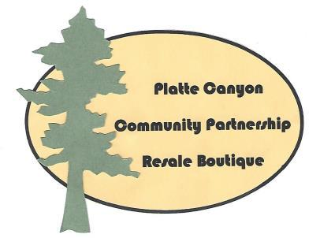

Platte Canyon Community Partnership Resale Boutique

PO Box 904, Bailey CO 80421
Phone 303-816-7423
Website pccpresaleboutique.org
Email: pccpresaleboutique@gmail.com

Volunteer Application

First Name: Last Name:

Address: City/State/Zip:

Phone Home/Cell: Date of Birth:

Email:

Physical Limitations: No Yes (please explain)

Education: (highest level completed): please circle

High School or Equivalent College Graduate School Technical/Vocational

Occupation:

Previous Volunteer Experience: Skills, Interests, Education that would be beneficial to the PCCP

1.

2.

3.

Volunteer Job Preferences: please circle

Manager Receiving Floor Building Maintenance Outside Maintenance

Special Events Other

Volunteer Availability: please circle all applicable (Shifts AM: 10-1 PM: 1-4)

Tuesday am/pm Wednesday am/pm Thursday am/pm Friday am/pm

Saturday am/pm No Preference

References (name/contact info): 1. 2.

Emergency Contact:

Volunteer Signature: Date:

Status Dates – Official Use Only: Staff – Please date and initial when accomplished

- Application received by (name and date):
- Application complete (this form, Liability Waiver, Policies Acknowledgement, Parental Consent – if under 18)
- Contact made
- General orientation
- Manager orientation
- Start date
- Notes
PE 8/31/2023

